Mid-Term Reflection on the Fundamentals of Data Science

Brayden Yates
University of the Cumberlands
MSDS-530: Fundamentals of Data Science
Dr. Jason Turner
3 February 2024

Mid-Term Reflection on the Fundamentals of Data Science
Data, information, knowledge, and wisdom are all interrelated, though different concepts. Data refers to the unprocessed, raw facts. Data could refer to raw test scores, or vitals in the doctor’s office. If we were to use self-driving vehicles as our example, we could consider the raw sensor readings such as GPS coordinates, speed, and radar/lidar scans as examples of data.
Information is essentially data with context applied to it. When we provide context and meaning to data, it becomes information. Information can answer many questions such as the 4 W’s: who, what, when, and where. If we consider self-driving vehicles again, we could use GPS coordinates to determine where the vehicle is. We could use speed to determine where the vehicle is going, and radar/lidar to determine what other vehicles or objects are near the vehicle.
Knowledge is information that has been interpreted to generate actionable insights. Using the information provided from our self-driving car’s sensors, a machine learning model could identify that our self-driving vehicle is at risk of colliding with the vehicle in front of it, or that the vehicle on the left is about to swerve into the self-driving vehicle. This would allow our self-driving vehicle to make a decision, such as braking or changing lanes.
Wisdom is knowledge applied with prior experience and foresight. If a self-driving vehicle is about to collide with the vehicle in front of it, it may determine the safest thing to do is to brake. It may also determine that the left lane is open, and it’d be safer to move to that lane in order to avoid a collision. This hierarchy can also be reversed. We can diffuse knowledge to gather information, and this information can be dismembered to provide raw data.

Variables and Measurement Scales
There are four primary types of variables—nominal, ordinal, interval, and ratio variables. Each of these has its own scale of measurement. Nominal variables, as the name implies, are names or categories. With nominal variable, there are typically two or more categories, but there is no specific ordering to these categories. Web browsers are a great example of a nominal variable. Someone could use Edge, Firefox, Chrome, Librewolf, Opera, Brave, Safari, or several other options. While one may have their own preference in this example, there is no clear ordering or hierarchy to web browsers.
Ordinal variables are very similar to nominal variables, however there is a distinct ordering of the categories. Many applications, such as insurance or job applications, ask for the highest level of education completed. There is a clear ordering: high school diploma, associate’s degree, bachelor’s degree, master’s degree, doctorate degree.
Interval variables are similar to ordinal variables. The difference lies in that the values of the variable are equaly spaced. If we are filling out an application that asks for income in $5,000 increments, this is an interval variable. This form might have the options $10,000, $15,000, $20,000, etc. which are all equally spaced in $5,000 increments.
Ratio variables are similar to interval variables though a value of zero truly means there is none of that variable. Temperature in Farenheit or Celsius is a ratio variable, as a temperature of zero does not mean that the atoms in the material are not moving at all. Temperature in Kelvin is a ratio variable, as a temperature of 0 degrees Kelvin is absolute zero. Height and weight are also ratio variables.
Descriptive Statistics and Bivariate Analysis
For this section, I will examine the fossil price data from Animal Crossing: New Horizions (Data spreadsheet for Animal Crossing New Horizons). Animal Crossing uses its own in-game currency known as Bells. Here is the code used to generate the frequency distribution of Animal Crossing: New Horizions fossil prices:
import pandas as pd
import matplotlib.pyplot as plt
df = pd.read_csv('fossils.csv')
fig, ax = plt.subplots()
df['Sell'].value_counts().plot(ax=ax, kind='bar')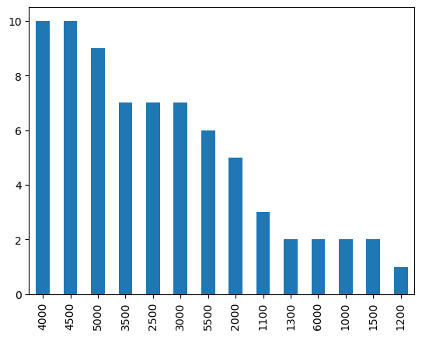
In order to get the common summary measures, I utilized this function and received this output:
df['Sell'].describe()
count 73.000000
mean 3563.013699
std 1402.924213
min 1000.000000
25% 2500.000000
50% 4000.000000
75% 4500.000000
max 6000.000000
Name: Sell, dtype: float64
We can gather some distinct insights about gameplay from this data. When beginning the game, a house costs 98,000 Bells. The average fossil in Animal Crossing sells for 3563 Bells, with a standard deviation of 1402 Bells. Fossils are also relatively simple to find, as their location is marked on the ground in plain sight. That means, on average, you would need to find 28 fossils in the game to pay off your mortgage. Over half of the fossils in the game sell for a price greater than 4000 Bells, and the fossil you discover is randomly selected. There is a high probability that you would be able to pay off your home mortgage by finding less than 28 fossils.
For our bivariate analysis, we will examine Animal Crossing Housewares data from the same dataset. For our qualitative variables, we will examine the association between Color 1 and Happy Home Academy Concept. Here is the code used to examine this data:
import pandas as pd
import matplotlib.pyplot as plt
import scipy.stats as stats
df = pd.read_csv('housewares.csv')
pd.set_option('display.max_columns', None)
pd.set_option('display.max_rows', None)
contingency_table = pd.crosstab(df['Color 1'], columns=df['HHA Concept 1'])
contingency_table
chi2, p, _, _ = stats.chi2_contingency(contingency_table)

print(f"Chi-squared statistic: {chi2}")
print(f"P-value: {p}")
chi2, p, _, _ = stats.chi2_contingency(contingency_table)
Our Chi Squared Statistic is 1414.79 with a P-value of 2.56.e-129. With such a low p-value, we can conclude that there is a statistically significant association between color choice and the Happy Home Academy concept. This indicates that there is likely a color theme for each room as part of the Happy Home Academy concepts.
For the quantitative variables, we will examine the correlation between the purchase price and selling price for these housewares. To clarify definitions, buy price refers to the price that the player purchases the item for, and sell price refers to the price that the player can sell the item for. Here is the code used to examine the potential correlation:
correlation = df['Buy'].corr(df['Sell'])

Running this function, we see a correlation of 0.999, meaning there is a strong positive correlation between buy and sell prices. Plotting the buy and sell prices, we can see that the price difference is linear:
plt.figure(figsize=(8, 6))
plt.scatter(df['Buy'], df['Sell'], alpha=0.5)
plt.title("Buy vs. Sell Prices")
plt.xlabel("Buy Price")
plt.ylabel("Sell Price")
plt.grid(True)
plt.show()

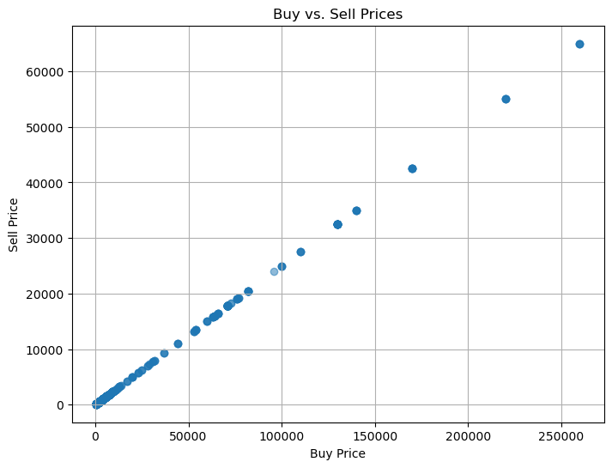
Probability and Distributions
Probability is a topic with great depth and potential insights, however it is based on some basic fundamental principles. The most fundamental of these is the idea of a random experiment. A random experiment generates unpredictable results. Short-term results are random in probability, so probability only applies over large measurements. As an example, flipping a coin twice will not always land on heads once and tails once. It could land on heads twice or tails twice as well. Another foundational principle is the idea of sample space. Sample space is simple—it is all of the possible results of an experiment. If I roll a 20 sided dice, my sample space is 1 through 20. An event is a subset of a sample space, such as rolling a number less than ten. Probability itself is a number between 0 and 1 that indicates the likelihood of something happening. When flipping a coin, the probability of landing on heads is 0.5, and the probability of landing on tails is 0.5. The sum of all possible events always equals one. This concept leads into another simple concept—the complement rule. This concept, in its simplest form, is that the probability of an event not occuring is equal to 1 – the probability that an event occurs (Favero 127).
Conditional probability is useful when events are not independent. Conditional probability is the likelihood that one event happens given another event that has already happened. Bayes Theorem comes into play with conditional probability. Bayes theorem, in its simplest form describes the chance of an event based on related events that have already occurred. A common example is medical testing. If you have a test for a very rare disease that will correctly diagnose you 99% of the time, and an individual tests positively for that disease, the immediate thought is that the individual must have this disease. However, that is not necessarily the case. If one million people have been tested, and the test correctly identifies 99% of them, this means that it incorrectly diagnoses 1% of the million people, or 10,000 people. In this case, your probability of actually having the disease is really 99 in 10,099 (The Guardian, 2021).
Discrete random variables are variables that utilize integers. Examples of discrete random variables include the number of people living in a household, or the amount of times a person goes to a gas station in a year. A continuous random variable takes on real numbers. This could be family income, or amount of money spent on gas in one year.
Sampling Techniques
There are many sampling techniques available to data scientists. The simplest and most frequent type of sampling is Simple Random Sampling. Using SRS, we typically use a random number generator, or draw out names to generate our random sample. Systematic sampling is frequently utilized in a production line, where quality assurance employees may remove one item in every fifty to collect data on quality. (Favero 171). Stratified Sampling is a form of sampling where the population is divided into subpopulations, and samples are drawn from each subpopulation. These divisions could be state, race, gender, or any other strata (Favero 172).
While the previously discussed techniques were random sampling techniques, there are also non-random techniques. The easiest form of nonrandom sampling is convenience sampling. In convenience sampling, the data scientist collects information from people who are chosen out of convenience. This could be family, students, or friends. Judgemental sampling is a sample chosen according to an expert opinion. There is a high risk of bias with this technique, as the researcher may have some implicit bias that effects the collected data (Favero 175). Quota sampling is a more rigorous form of nonrandom sampling. It is commonly used in market surveys and election polls (Favero 175). In quota sampling, the researcher selects the control variables that are relevant for the study, then determines the percentage of the population that fits into each of these variables. Then, the quota size is calculated to determine the number of people that need to be interviewed such that the sample has the same proportions as the population (Favero 175).
Every year, I attend the Kentucky Music Educator’s Professional Development Conference. During the conference, I require all of my students to fill out a survey to collect data on the health and status of the program. Many of the questions in the survey are jaded, however the survey is anonymous to encourage students to be honest. I ask students about the reasons they participate in band, why they enjoy the class, as well as the things they do not like about band class. I also ask them to self-assess the things they feel like they do well at and the things they struggle with. This is an example of convenience sampling, however it is extremely effective for my particular situation. While this is a convenience sample, the sample is a survey of the entire population of the program. This means the only inaccuracy in the data comes from variables such as student’s not being entirely honest on the survey, or hyperbolizing on the survey.
References
Google. (n.d.). Data spreadsheet for Animal Crossing New Horizons. Google Sheets. https://docs.google.com/spreadsheets/d/13d_LAJPlxMa_DubPTuirkIV4DERBMXbrWQsmSh8ReK4/edit?pli=1#gid=400375391
Guardian News and Media. (2021, April 18). The obscure maths theorem that governs the reliability of Covid testing. The Guardian. https://www.theguardian.com/world/2021/apr/18/obscure-maths-bayes-theorem-reliability-covid-lateral-flow-tests-probability

